

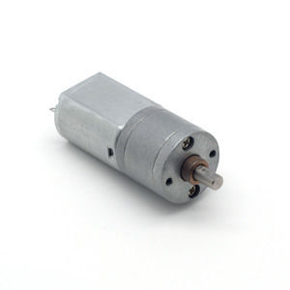

#### LDO-20GM130 Series

**SPECIFICATIONS:**

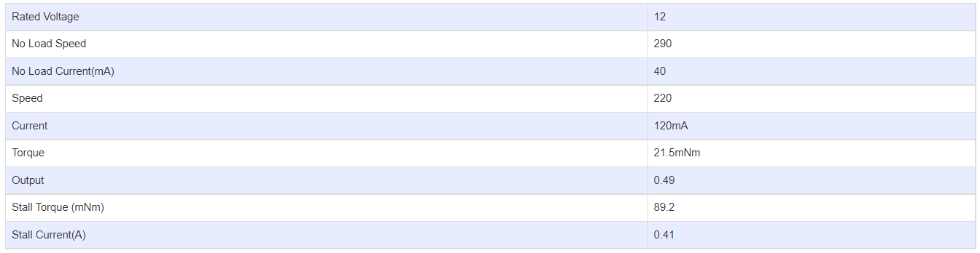

**GEARBOX OPTIONS:**

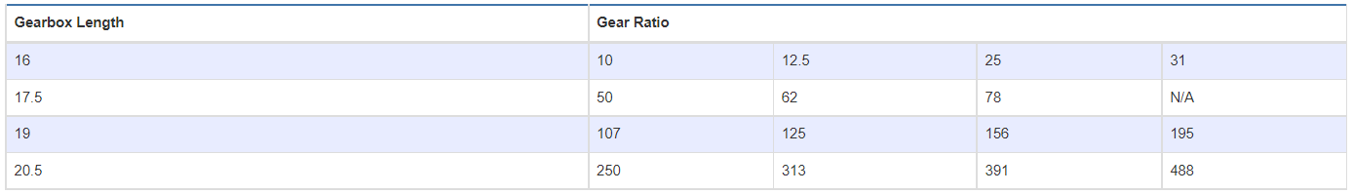

**SUBMODELS:**

*The following are common submodels for the LDO-20GM130 series.*

